

Module Code | : | SNA Nov 112025 (MGR)
Intake Code | : | APD2F2511CS(CYB)
Lecturer Name (L) | : | Ts. Dr. Manimegalai Rajenderan
Lecturer Name (LAB) | : | Ts. Dr. Derrick Chow Kam Yuem
Hand in / out Date | : | Sunday, 25 January 2026 / Monday, 9 February 2026
Group | : | BQA
Group Leader | : | Ibrahim Ali Mahalla

Student TP | Student Name
TP086792 | Ibrahim Ali Mahalla
TP080443 | OMAR ABDULMUNEM MOHAMED MARYUL
TP086834 | Faysil Wannees Abraheem Shabeesh
Tp087038 | Chit Swan Lyan Khant Kyaw
TP075202 | MUSTAFA MOHAMMED MUSTAFA

Table Of Content
Workload Matrix: 2
1.0 INTRODUCTION: 3
2.0 DNS SERVER CONFIGURATION: 3
2.1 Objective: 3
2.2 Network & Host Configuration: 4
2.3 DNS Zone Configuration: 7
2.4 Reverse Zone Configuration: 9
2.5 DNS Service Verification: 10
2.6 DNS Testing from Rocky Server and Ubuntu Client: 11
2.7 Task Outcome: 12
3.0 EMAIL SERVER: 12
3.1 Objective: 12
3.2 Email Server Installation: 13
3.3 Email Service Status and Firewall Configuration: 13
3.4 SSL/TLS Configuration: 14
3.5 Thunderbird Client Configuration: 16
3.6 Task Outcome: 20
4.0 Web Server Configuration: 20
4.1 Objective: 20
4.2 Apache Installation and Service Verification 21
4.3 Starting and Verifying Apache Service: 21
4.4 Firewall Configuration: 21
4.5 Website Configuration: 22
4.6 HTTPS (SSL/TLS) Configuration: 23
4.7 Client-side Verification (Ubuntu Client): 23
5.0 Additional Service: Database Server (MariaDB): 24
5.1 Objective: 24
5.2 Install MariaDB Server (Rocky Linux): 24
5.3 Service Enablement and Status Verification: 24
5.4 Securing the Database Server: 25
5.5 Create Database and User: 27
5.6 Database Access from Client (Ubuntu): 27
6.0 TROUBLESHOOTING AND PROBLEM RESOLUTION: 29
6.1 DNS Service Failed to Start (BIND): 29
6.2 Thunderbird Unable to Log In to Mail Server: 31
6.3 HTTPS Security Warning When Accessing the Web Server: 33
6.4 ISSUE IN Database Serve: 35
7.0 CONCLUSION: 37
8.0 References: 38

Workload Matrix:

 | Student 1  TP086792 | Student 2  TP080443 | Student 3  TP086834 | Student 4  Tp087038 | Student 5  TP075202
DNS SERVER CONFIGURATION | 16.6% | 16.6% | 16.6% | 16.6% | 16.6%
EMAIL SERVER | 16.6% | 16.6% | 16.6% | 16.6% | 16.6%
Web Server Configuration | 16.6% | 16.6% | 16.6% | 16.6% | 16.6%
Database Server (MariaDB) | 16.6% | 16.6% | 16.6% | 16.6% | 16.6%
Troubleshooting | 16.6% | 16.6% | 16.6% | 16.6% | 16.6%
Conclusion | 16.6% | 16.6% | 16.6% | 16.6% | 16.6%

1.0 INTRODUCTION:

The following activity will be devoted to the process of installation, configuration, and testing of a collection of network services on a server based on Rocky Linux that will be linked at the client side by an Ubuntu system. The primary goal of the specified project is the demonstration of the effective skills of the server administration, the networking services, and the safe communication between the customers and the server in the regulated conditions within the laboratory.
The services offered to this assignment include Domain Name system (DNS) server that will be implemented with BIND, email server that will be implemented with Postfix and dovecot, and web server that will be implemented with Apache that will help to support the usage of an SSL/TLS protocol. Moreover, the second service as a MariaDB database server is added to respond to the demand of an additional functionality in comparison with the core services.
All the services are configured, tested, and verified on server and on the other side of the client to guarantee that it is fully operational. They also undertake the security measures that are undertaken on periodic basis such as encryption of the information due to the usage of the SSL/TLS, firewall settings and the secure authentication settings to offer protection to the data transfer and access of the systems.
Besides, the assignment provides real life troubleshooting scenarios that had been realized during the implementation process. These issues are discussed, addressed, and better illustrated to show the capacity to resolve issues and deeper understanding in the concept of system administration.
.

2.0 DNS SERVER CONFIGURATION:

2.1 Objective:

The specified task is task-based in terms of installation and configuration of Domain Name System (DNS) server on the Rocky Linux server with the help of the BIND. This DNS server is supposed to be configured to answer the local Fully Qualified Domain Names (FQDN) and foreign domain names. The testing of the DNS functionality is completed in the Ubuntu Linux client system.
The domain name was the BQA and this is exhibited by the assignment requirement.
- Domain Name: BQA.com
- Server FQDN: server.BQA.com
- Client FQDN: client.BQA.com

2.2 Network & Host Configuration:

Before the DNS services are configured to establish a stable communication between systems, network and hostname configuration must be undertaken:
System | IP Address
Rocky Server | 192.168.200.4
Ubuntu Client | 192.168.200.81

(1) Static IP Configuration (Rocky Linux Server):

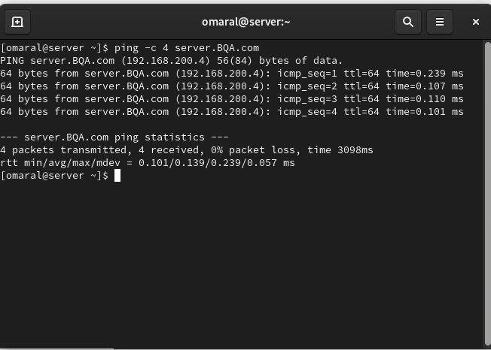
Figure 1: Ping server connectivity
This step to configuration was made to enable Rocky Linux server network interface to operate using a fixed IP address by making amendments in the file, ifcfg-eth0, in the folder, /etc/ sysconfig/network-scripts/ of the configuration. It is set to BOOTprotostatic and ONBOOTyeset such that when booting the interface is auto-set. Outbound address was set to 192.168.200.4 with a subnet mask of 255.255.255.0 and default gateway was changed to 192.168.200.1 and allowed outbound connections. There were also DNS resolvers (e.g. 8.8.8.8) where the server can resolve domain names on a regular basis so that the network communication can be extremely stable.

(2) Hostname Mapping (Ubuntu Client /etc/hosts):

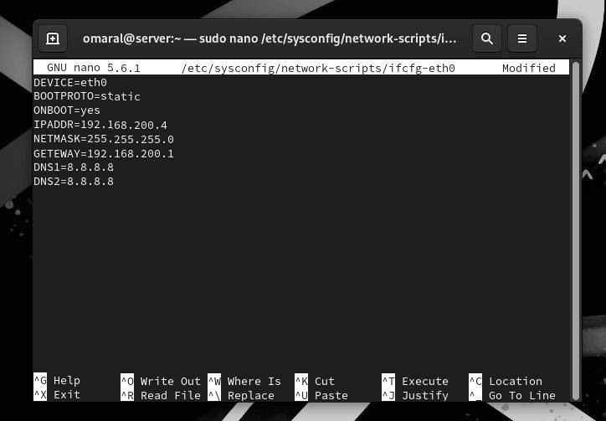
Figure 2: Static IP config (eth0)
The mappings of the hostnames IP local between the client and the server were done by altering host file /etc/hosts on the client machine that was Ubuntu. hostnames 192.168.200.4 server.BQA.com server and 192.168.200.81 client.BQA.com client were configured in such a way that the two systems would be capable of resolving each other despite the fact that all external DNS was used in the original set up/testing. This not only makes the name resolution process faster but also reliable in the lab net, but will also make it simple to guarantee that it is simple to establish that it is appended by hostnames but not by IP addresses as such.

(3) Connectivity & Name Resolution Testing (Ping):

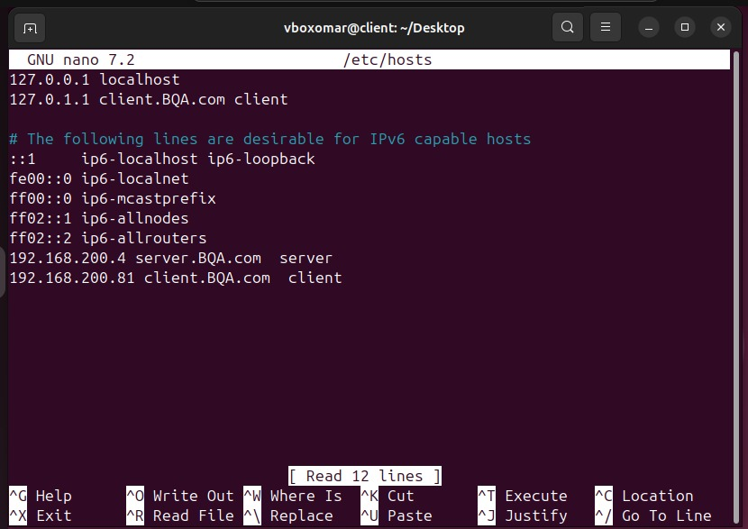
Figure 3: /etc/hosts name mapping
After the network and host configuration was done the connectivity was verified with the ping -c 4 server.BQA.com. The output showed that the host name server, BQA.com had resolved experience successfully to 192.168.200.4 and all four ICMP packets were successfully received without the packet loss (0 percent) that indicated that the network communication was healthy. The test is applied to make certain that the fundamental network reachability and excellent hostname resolution are functioning correctly that the network configuration and hostnames entries are functioning properly.

2.3 DNS Zone Configuration:

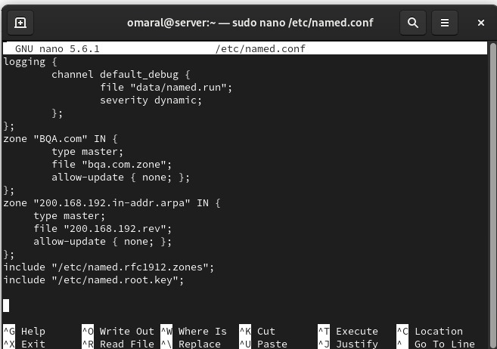
Figure 4: BIND named.conf zone setup
This DNS is realized in the BIND configuration files too whereby the network arrangement is finished.

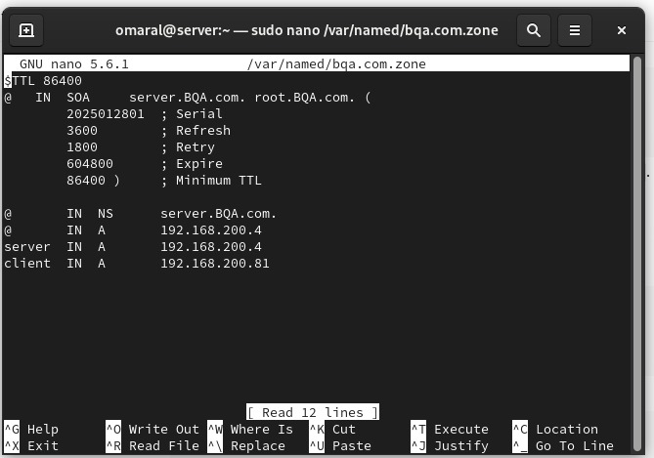
Figure 5: Forward DNS zone file

BQA.com inverted DNS zone is built. This zone file contains:
- SOA Record (Start of Authority).
- NS (Name Server) record. -
- A database at the server and the client.
This will facilitate such areas as server. BQA, com, client. BQA, com to be changed into respective IP addresses

2.4 Reverse Zone Configuration:

It also offers reverse DNS zone in which the domain names are allotted the IP addresses. PTR records are made to match:
- 192.168.200.4 with server.BQA.com
- 192.168.200.81 with client.BQA.com

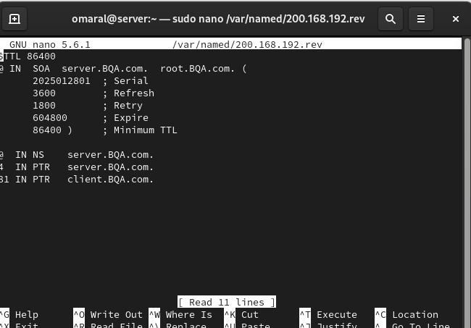
Figure 6: Reverse DNS zone file
One of the screenshots that one can see to get the main DNS server (server.BQA.com) and the administrative address and vital zone timers such as serial number, refresh, retry, expire and minimum TTL is a screenshot of the writing of the DNS reverse lookup zone file of the BIND on the Rocky Linux server with sudo nano /var/named/ 200.168.192.rev. SOA (Start of Authority) record of this file. Then comes an NS record listing server.BQA.com as a name server of this reverse zone which is an authoritative one. Finally, the IP addresses will have been returned on PTR records in both IP (e.g. 4 IN PTR server.BQA.com. and 81 IN PTR client.BQA.com) and reverse reverse DNS is achieved (e.g., 192.168.200.4 will be resolved to server.BQA.com and 192.168.200.81 to client.BQA.com).
.

2.5 DNS Service Verification:

Once the DNS configuration files had been filled, a restarted and tested BIND service is tested. It does not experience issues with its service and thus can be assured that it is operational as shown by the state of its service.

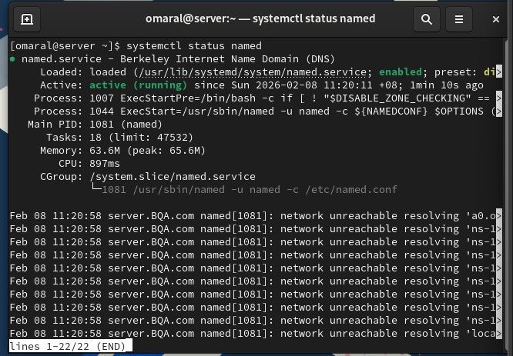
Figure 7: Named service status check
The status of the BIND DNS are revealed by the systemctl status named shown in the below screen shot. The output also supports the fact that the loaded service is present, it will be automatically started (enabled) and running (running) at the current moment as well, thereby, it can be concluded that the DNS server is already successfully operating on the Rocky Linux machine. It also presents required run time details such as process ID of main, memory usage and lastest log messages. The large number of network unreachability resolving messages is an indication that the DNS service started and tried to access external/forwarder DNS or root servers and was experiencing a network reachability error- this is normal when the internet is blocked or routing/DNS forwarding cannot occur but not necessarily when the lab network is under local zone resolution.

2.6 DNS Testing from Rocky Server and Ubuntu Client:

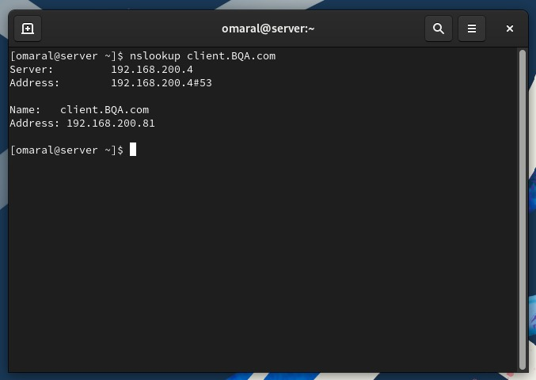
Figure 8: Nslookup client DNS record
The following is a screen shot of a successful DNS search test and it invoked nslookup client.BQA.com. What the output shows is that the server at the port 53 is responding to the DNS query with a server of 192.168.200.4 which is a testimony to the fact that the server at port 53 is the DNS resolver and that is the Rocky Linux server. Then it can locate hostname client.BQA.com and 192.168.200.81 IP address showing that forward DNS zone database is configured correctly and is operational as it is expected in the network.

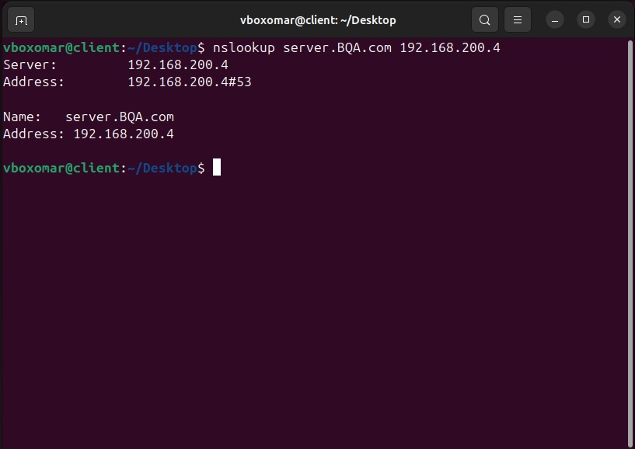
Figure 9: Nslookup server DNS record
An nslookup command is used to determine DNS resolving on Rocky Linux server and Ubuntu client. The correct answers are needed in such a way the DNS server is ready to respond to forward and reverse lookups.

2.7 Task Outcome:

Rocky Linux BIND had been installed and configured successfully with DNS server. The DNS server is configured up to a stage whereby it is responsive to the Full Qualified Domain Names (FQDN) of the client computers and the server computers respectively. The DNS resolution with the help of Ubuntu client was also tested and it was ascertained that DNS resolution is fully operational and is appropriate to the assignment conditions..

3.0 EMAIL SERVER:

3.1 Objective:

It will be done through installing safe email server in Rocky Linux server with postfix to send email and dovecot to receive email. To make the secure transmission, the implementation of the encryption of the encryption offered by theSSL/TLS is realized. Ubuntu client is also tested in terms of email sub-system.
Domain Used:
- Domain Name: BQA.com
- server.BQA.com , Server Fully Qualified Domain Name
- Client FQDN: client.BQA.com

3.2 Email Server Installation:

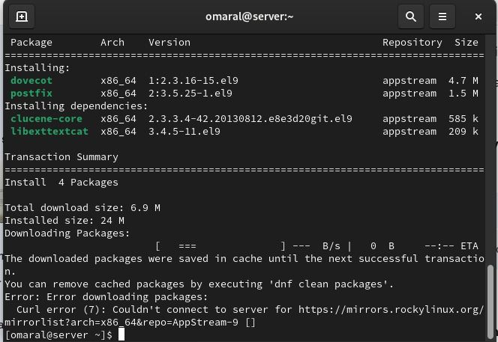
Figure 10: DNF repo connection error
It has postfix and dovecot installed on the Rocky Linux server with the help of package manager. These services will also contain SMTP, IMAP and POP3 services which are required during email communications.

3.3 Email Service Status and Firewall Configuration:

Dovecot service is then started and it is announced that the service is running. Firewall policies will be created which will allow permitted ports of email such as:
- IMAP (143)
- POP3 (110)
- SMTP (25)
This is to make accessibility to email server Notwithstanding the client system possible.

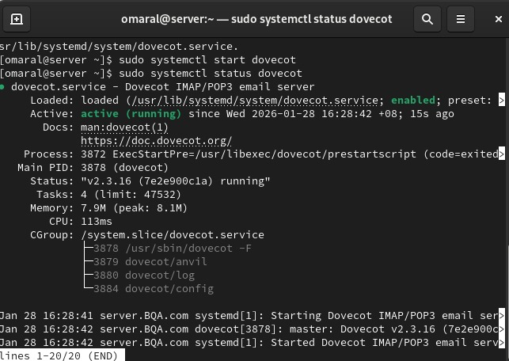
Figure 11: Dovecot service status
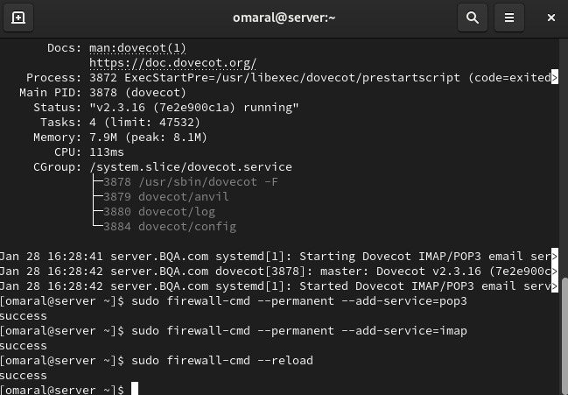
Figure 12: Firewall IMAP/POP3 rules

3.4 SSL/TLS Configuration:

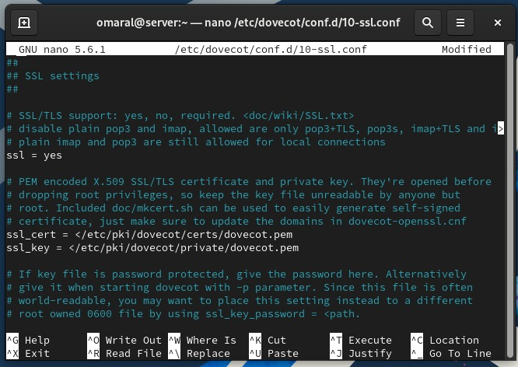
Figure 13: Dovecot SSL config
This is a screen capture that is an editing of the dovecot settings to the file /etc/dovecot/conf.d/10-ssl.conf to determine the provisioning of security to the IMAP/POP3 email access. Here, we can take the ssl = yes to enable us to obtain an encrypted communication with the email client where an email client is supposed to connect with the server using the ssl. It is also the installation that V decides the location of the server certificate along with the private key (which is /etc/pki/dovecot/certs/dovecot.pem and /etc/pki/dovecot/private/dovecot.pem). Such environments will see Dovecot provide a partial encrypted authentication and encryption of the data transmission where the usernames/ passwords and email messages will not be transmitted in the network between the users and the servers.

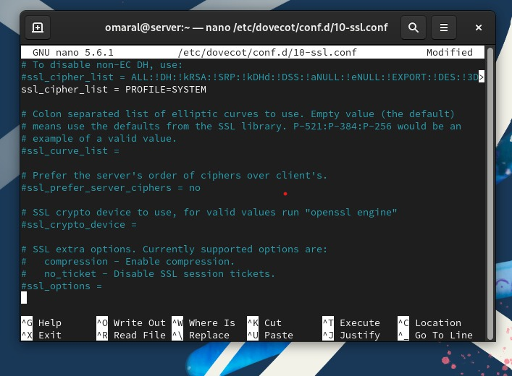
Figure 14: SSL cipher profile
The dovecot is configured to incorporate the use of inbuilt self-signed certificate by ensuring that the SSL/TLS is enabled. The transfer of authentication credentials or email contents will be done through encrypted messages hence their security.
This is accomplished through using a powerful cipher policy in order to enhance security and what is used are system-specified encryption parameters.

3.5 Thunderbird Client Configuration:

Ubuntu client has mozilla thunderbird which is installed and configured to connect to the email server.
The following will be specified manually as follows:

- Incoming server protocol: IMAP
- Incoming server hostname: server.BQA.com
- Outgoing server (SMTP): server.BQA.com
- Authentication using local user credentials

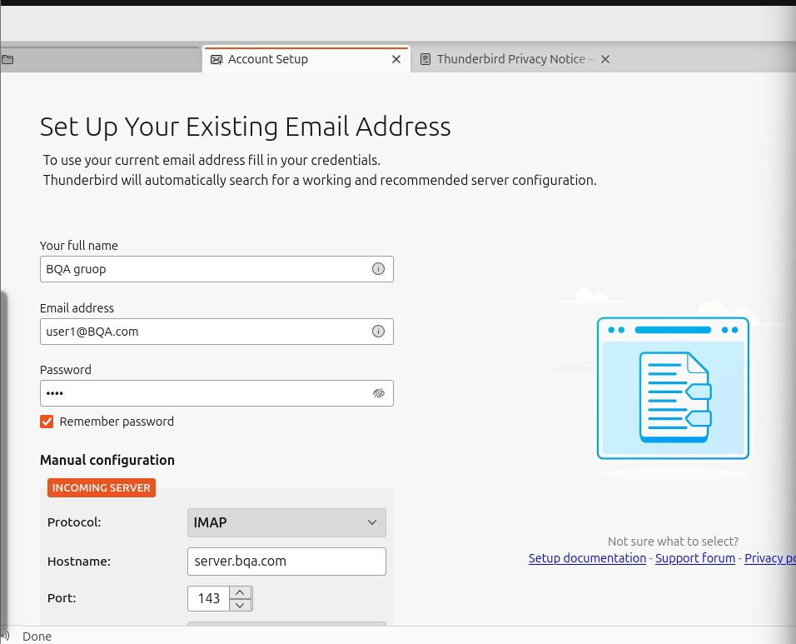
Figure 15: Thunderbird account setup

This screen shot can be seen as the first step in the creation of an email account in a Mozilla thunderbird account under a preexisting address user1@BQA.com. He/she will give his display name (e.g. BQA group), email address and a password and will go ahead to manual configurations to configure the correct mail server settings. Similar to the situation with the incoming mail service, IMAP will be selected to synchronize the emails with the server and a host name will be configured to server.bqa.com with default port of 143 IMAP to enable Thunderbird to connect with the Dovecot IMAP service that is being configured on the Rocky Linux server.

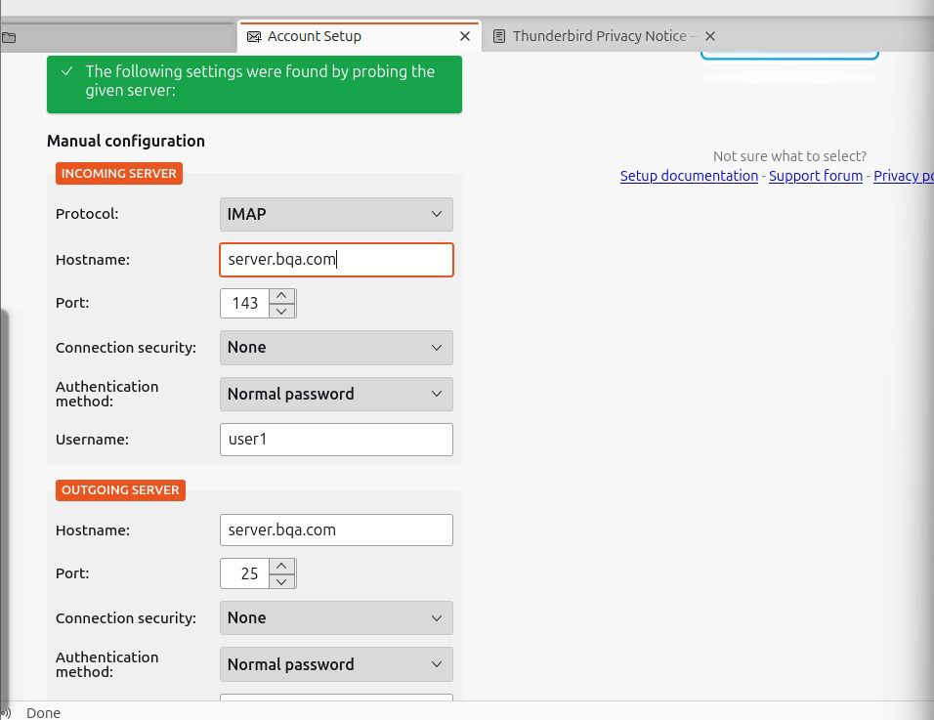
Figure 16: Thunderbird manual settings
The screen shot of the default server setup fine tuning is as follows in the quest to interrelate with the mail server. It is set to IMAP on Incoming Server with hostname server.bqa.com with a port of 143, authentication of the type as a Normal password and user1. The hostname of the Outgoing Server (SMTP) as well as the port of 25 of the server.bqa.com, is the one where Postfix can use to relay the mail to the rest of the network. The message of green at the top reveals why thunderbird has been in a position to probe and therefore, identify settings that are workable and therefore the reason why the services of both IMAP (Dovecot) and SMTP (Postfix) have been made available to the client system.

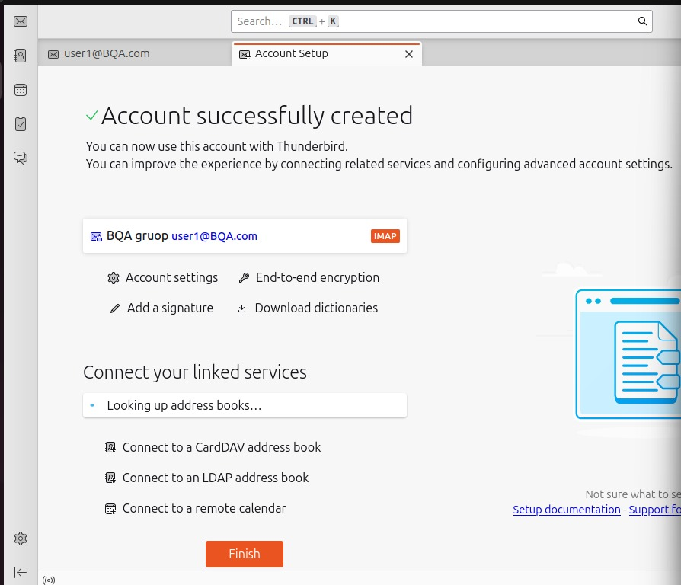
Figure 17: Account created successfully
This screen shot confirms the fact that the process of establishing the email account was a success because the account was established successfully as seen in the message bearing a check mark next to the message. Thunderbird has already been set up with user account user1 at BQA.com and IMAP is also enabled such that the user1 will be able to log in, synchronize folders, as well as receive mails; he can also send messages through SMTP server which has been configured. The reality that the last screen presents the data that mail server setup of the rocky Linux is in order and the end to end email client connectivity and authentication is in order shows that whatever is required was done.
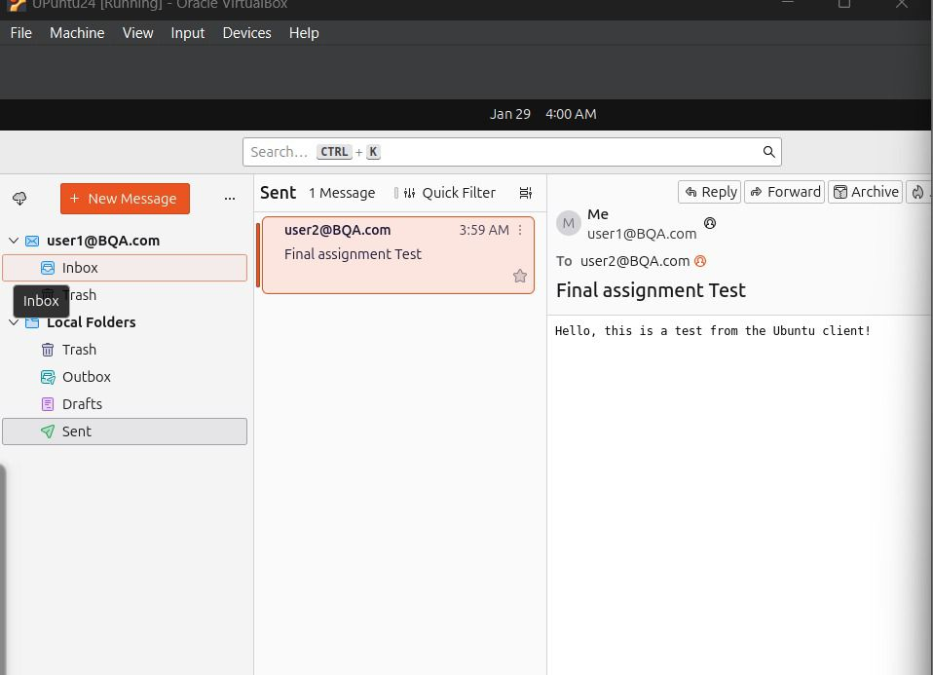
Figure 18: Test email sent
The accounts have been installed and Tests emails are received and sent amongst the users of the local area and, as such, the email server has been brought to functionality.

3.6 Task Outcome:

The email server is completed and configured successfully using the assistance of Postfix and dovecot with a base with the assistance of the help of the SSL/TLS and encrypted. To satisfy the assignment requirement, Thunderbird on Ubuntu client was then tried to offer secure email service between two local users.

4.0 Web Server Configuration:

4.1 Objective:

This assignment would require installation and configuration of the Apache web server on the Rocky Linux server in a way that would make it available to one of the clients of Ubuntu in a reasonable manner. Besides, the communication is secure due to the application of the HTTPS/SSL (SSL) which is activated during the communication.

4.2 Apache Installation and Service Verification
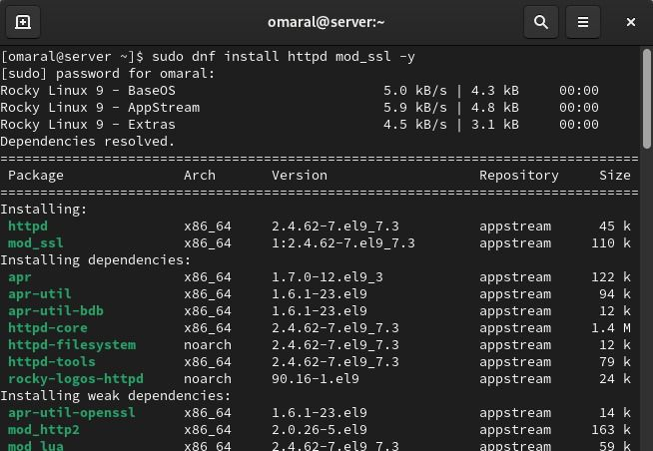
Figure 19: Install Apache mod_ssl
The server has Apache HTTP server and a server called the SSL installed in Rocky Linux server.

4.3 Starting and Verifying Apache Service:
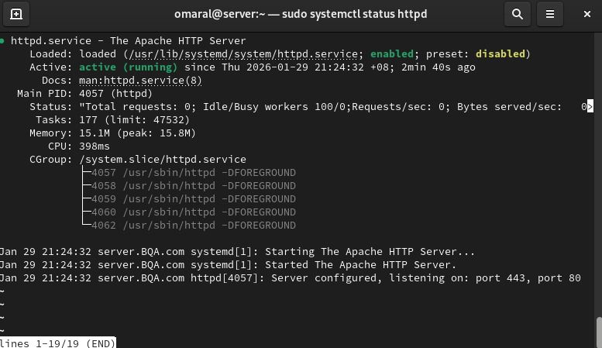
Figure 20: Apache httpd running
One then starts the service, makes sure that it is starting and then switches on the service.

4.4 Firewall Configuration:

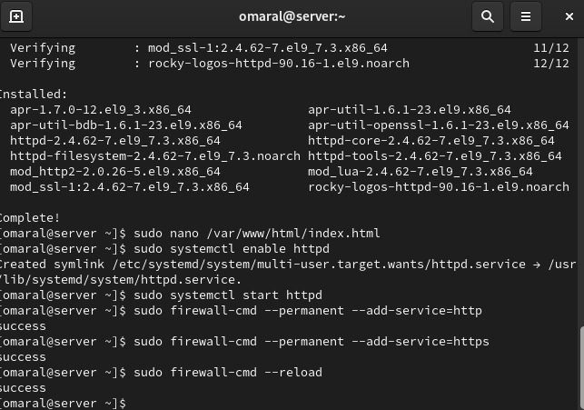
Figure 21: Apache package verification
Rules on firewalls are updated with the web traffic:
- HTTP (port 80)
- HTTPS (port 443)
Availability of web server is also external.

4.5 Website Configuration:

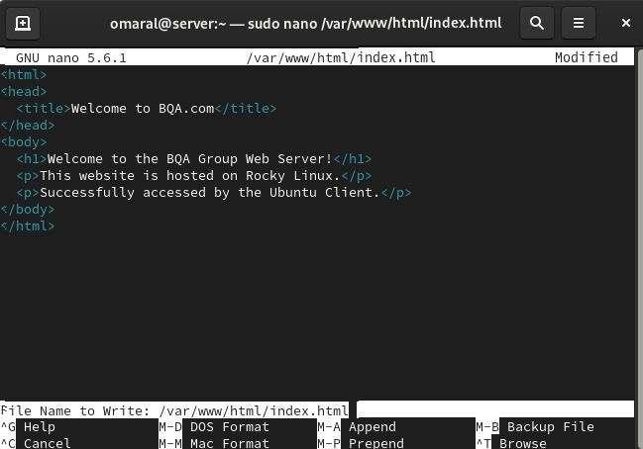
Figure 22: Web server HTML editing

4.6 HTTPS (SSL/TLS) Configuration:


Figure 23: HTTP service status check
It utilizes Apache SSL module which gives it the aid of utilization of the use of theSSL/TLS. This allows a secure HTTPS transmission of the web server.

4.7 Client-side Verification (Ubuntu Client):

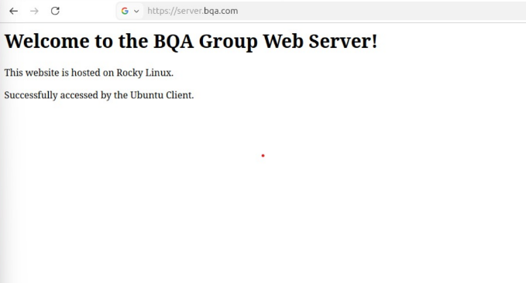
Figure 24: Webpage access confirmation
It can be accessed by the user through the aid of the web browser since it is in the form of a https connection to server.BQA.com and successful opening of the page is the signifier that the web server and Mozilla Secure Locksett are both configured appropriately.

5.0 Additional Service: Database Server (MariaDB):

5.1 Objective:

MariaDB is also selected to be another service to ensure that one of the requirements of the assignment is fulfilled that is the addition of one more feature on the server side. In the database server, access control, interaction between the clients and the server and access control are observed.

5.2 Install MariaDB Server (Rocky Linux):

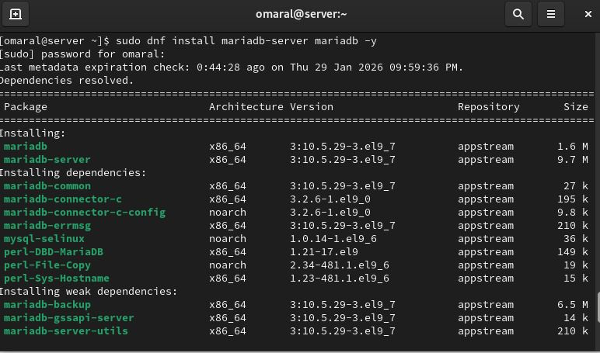
Figure 25: MariaDB service Installation
Rocky Linux supports the use of package manager in which packages of MariaDB server are installed.

5.3 Service Enablement and Status Verification:

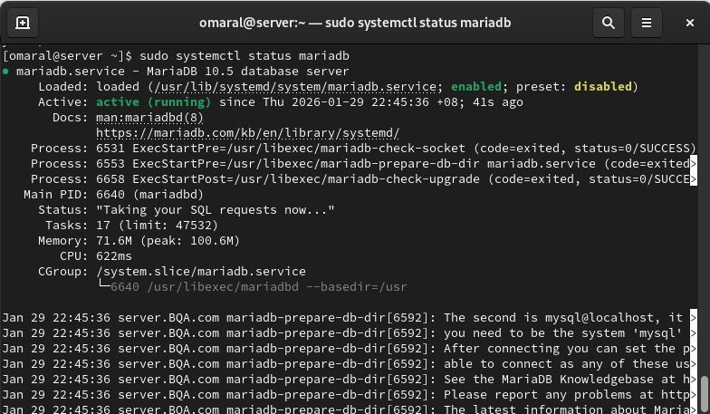
Figure 26: MariaDB service Installation

MariaDB service is also set and activated to roll out automatically when it is booted into the system. Successful state of operating service.

5.4 Securing the Database Server:

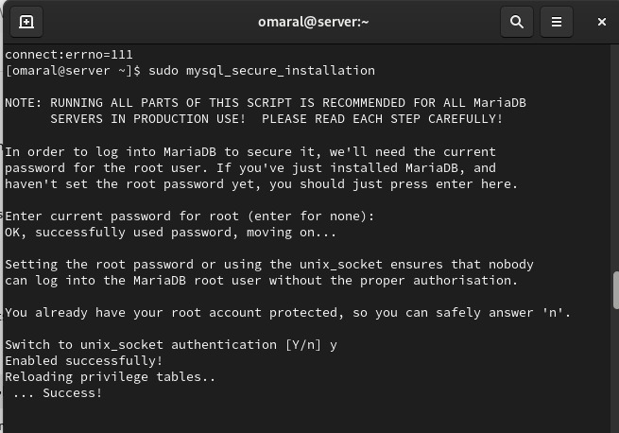
Figure 27: MariaDB secure installation part 1
It is a screen shot and when a person uses it he or she would be able to see how sudo mysql-secure-installation which is a default script to be used after the installation of a fresh MariaDB can secure the system. Once an input of the current root password (or even the absence thereof) has been made the script will enter into a series of more rigorous authentication procedures. In this case the unix socket authentication was on ( Switch to unix socket authentication [Y/n] y ) and MariaDB root user was able to log in the network without password as MariaDB root user was able to use sudo to log into network and impersonate a valve of the local system which was the root user. It also alters privilege tables thus rendering the changes effective instantly so that the unauthorized users cannot easily make themselves the administrators.

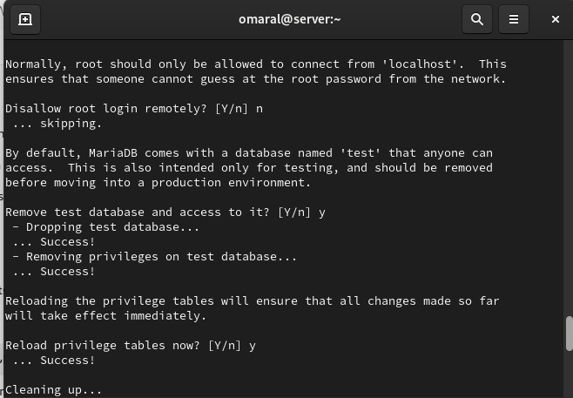
Figure 28: MariaDB secure installation part 2
The following are the screen shots of the further steps of the same hardening script in which some crucial security decisions have been made. It gives a warning of disabling remote root login which is good so as to stop an attacker who attempts to attack the database root account over the network (in the screenshot n was not chosen and hence there was no remote root restriction that was carried out). The default database of the script will then be killed ( Remove test database and access to it?). y) because it can be misused, is unnecessary in the manufacturing. And finally, it reload the privilege tables ( Reload privilege tables now? y) to be able to make the permission and security changes as soon as possible, in order to complete the MariaDB security configuration.

5.5 Create Database and User:

A database called bqa_db is created and special database user is created. The respective privileges are granted in a way that facilitates the access of the database to be limited.
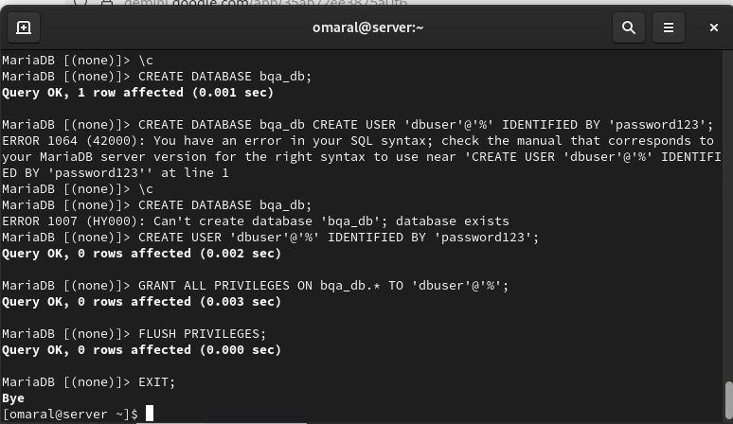
Figure 29: Database and user creation
The next screen shot was the opening of MariaDB server terminal and the successful creation of a new database called bqa-db (CREATE DATABASE bqa-db;). The previous one was that the user had executed CREATE DATABASE bqa_db; CREATE USER... on one erroneous query and then the message of database exists was then returned when the user had executed the command a second time. After the commands are fixed, a database user having remote access dbuser at was created in which full privileges and password were given on the database by the GRANT ALL PRIVilegES ON bqa_db command. TO dbuser percent to alter the existing time FLUSH Privileges. This means that the database was properly set up to permit restricted access and connectivity.

5.6 Database Access from Client (Ubuntu):

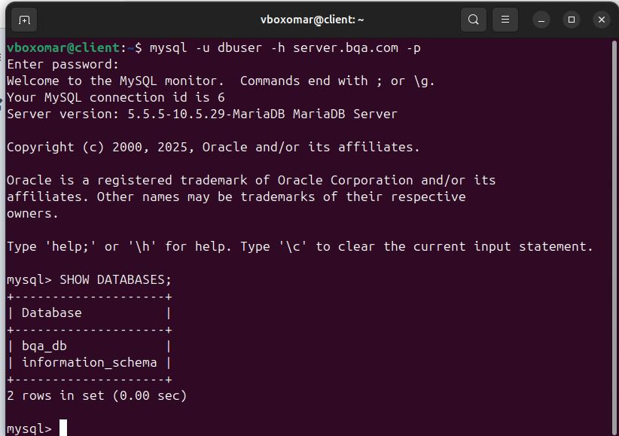
Figure 30: Remote MySQL connection
As can be observed in this screen shot the Ubuntu client has been used to access remotely the MariaDB manually with the following command mysql -u dbuser -h server.bqa.com -p which is a pointer that the server is online and the user login credentials that were generated are valid. The information schema of the default is also shown when the following command SHOW DATABases was typed; bqa_db is the default database and indicates the client can communicate with the server and access the assigned database. This implies that the interaction between the client and server database e.g. hostname resolution (server.bqa.com) and authorization to the remote user is occurring as expected.

6.0 TROUBLESHOOTING AND PROBLEM RESOLUTION:

6.1 DNS Service Failed to Start (BIND):

After the DNS reverse zone file had been set up, and a restart command had been issued to the BIND service the named service refused to boot. The system responded with error wherein the service got terminated with error code.
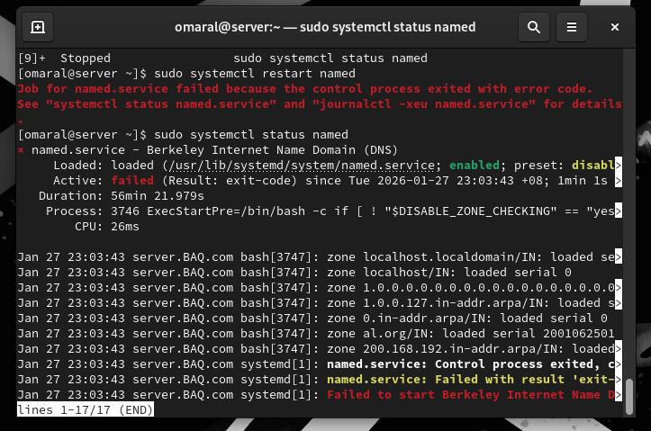
Figure 31: Troubleshooting For Bind Server
It was determined by application of the files of DNS configuration that the problem had been brought about by the inconsistent domain name in reverse DNS zone file.
The proper domain name to be used in the project is the following:
BQA.com
However with the reverse zone file (200.168.192.rev) the reverse typed domain name was entered:
BAQ.com
This discrepancy between the domain name identified by the named.conf and the reverse zone file caused the zone of DNS not to load and this caused DNS service to start.

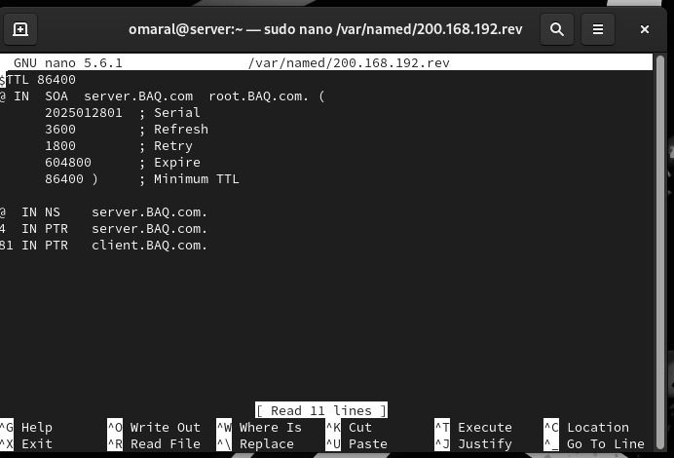
Figure 32: DNS reverse zone editing
In order to address this issue, there was a need to edit a reverse zone file by making the replacement of the domain name with the right project domain.

Figure 33: DNS reverse zone updated

Wherever the wrong domain name BAQ.com was found it was changed to BQA.com.
There was another bootstrap to the DNS service.
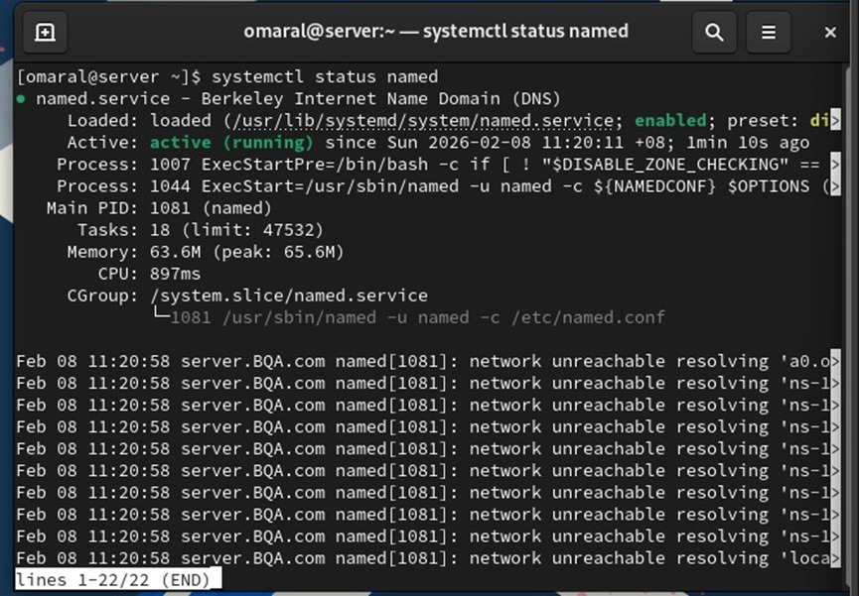
Figure 34: DNS service status
The DNS service was eventually started after the check that the inconsistency of the domain names had been cleared. This server had the capability of loading forward and reverse DNS zones and there was no error, and complete recovered DNS functionality.

6.2 Thunderbird Unable to Log In to Mail Server:

Issue description:
In the ubuntu system, the email setup was not successful and therefore Thunderbird email client was not configured. When I attempted to enter the account manually Thunderbird gave me the following error:
“Unable to log in at server. Most likely invalid, user name or password.
This has been encountered in a bid to gain access to email server that has been established in the Postfix and dovecot in the Rocky Linux server.

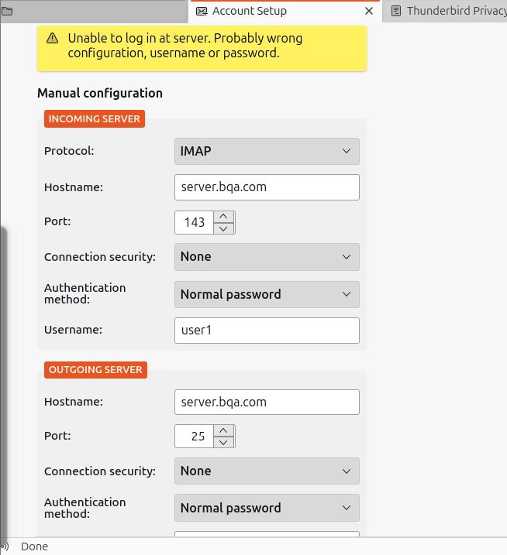
Figure 35: Email configuration attempt


Figure 36: Email server probing
The problem came about as a result of server-side configuration problems. The email services were not correctly configured and functional on Rocky Linux server despite email client settings (IMAP protocol, hostname, and ports and username) proved to be legitimate. When the server configuration was rectified, the Postfix and dovecot services were added, the client identified the mail server.

Figure 37: Email account creation success

After adjusting the mail server settings by making the required corrections and enabling all the required services, the email account was successfully created in Thunderbird. Internet message access protocol allowed the client to exchange information with the server and this is what made the email service to be running.

6.3 HTTPS Security Warning When Accessing the Web Server:

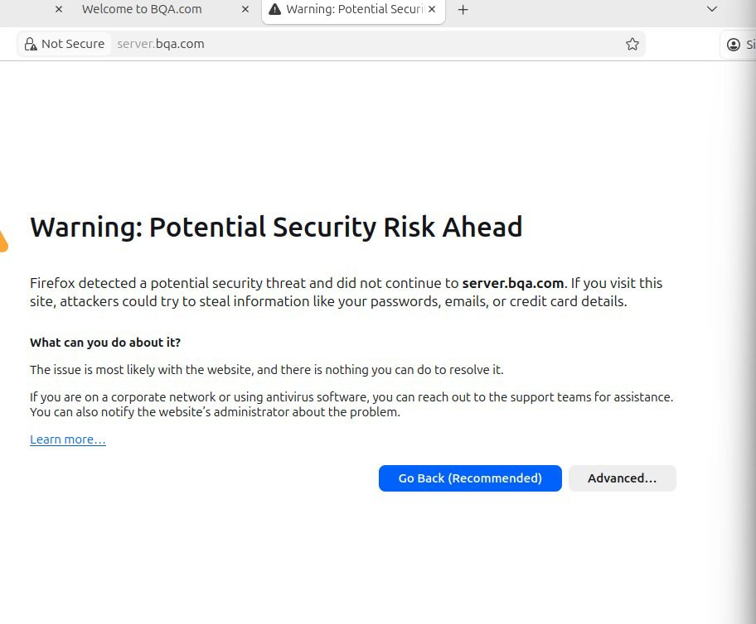
Figure 38: SSL warning in browser

Issue Description:
Since the Ubuntu client was connecting to the Apache webserver via HTTPS, the browser issued a security warning on the potential security-threat. Firefox has also acted as a barrier to the connection with the OOIP server.bqa.com since it failed to have authenticated certification of the SSL/ TL certificate and lack of trust.
This was the issue of that the self-signing certificate of the web server was put in place. It was not signed by a familiar Certificate Authority (CA) and hence the browser did not verify it hence a warning against insecurity was developed to maintain the user.

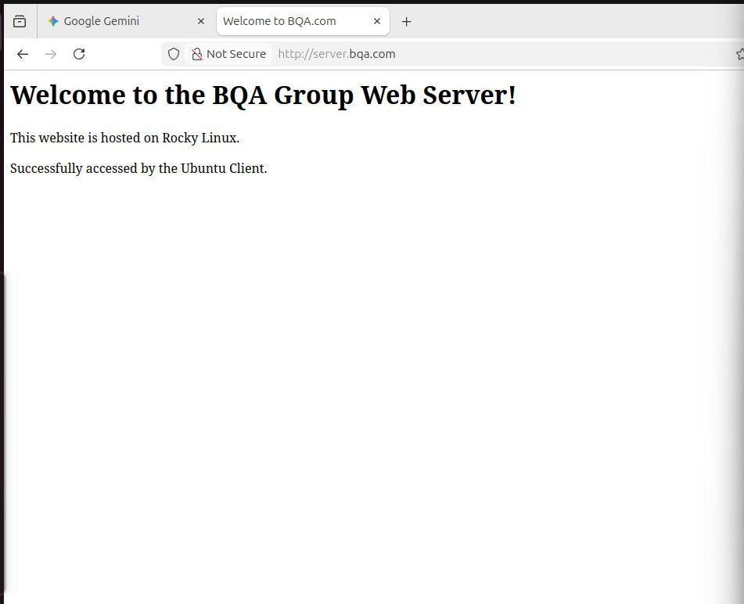
Figure 39: Successful web access after SSL

Resolution:
Apache webserver had also been experimented and known to contain the right set up of the SSL/TLS. The alert was to be alerted through raising with the use of self-established certificate. After loading the certificate successfully in the browser the site loaded correctly and it was certain that the secure web service was operating as it was projected.

6.4 ISSUE IN Database Serve:

Issue Explanation:
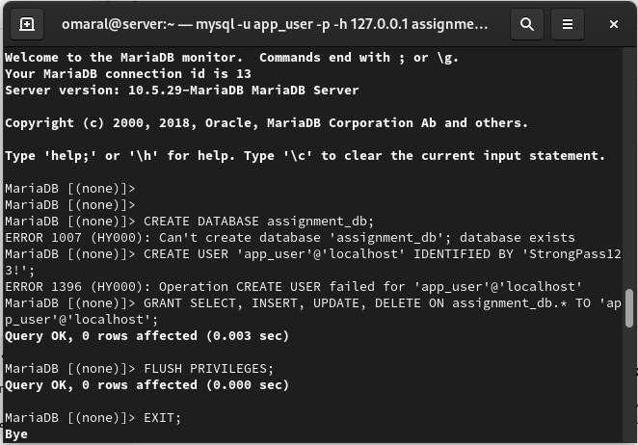
Figure 40: Database and user creation errors
Some of the mistakes that had been made during the process of setting the database include the effort of creating a new database and a new user of the database. It was giving out an error message of how the given system failed to generate user account since the database already existed.
The issue was, that the database and database user is made somewhere in a preceding step of configuration. MariaDB will not permit the two names of databases and the two user accounts, and this is why the specified errors took place as well.
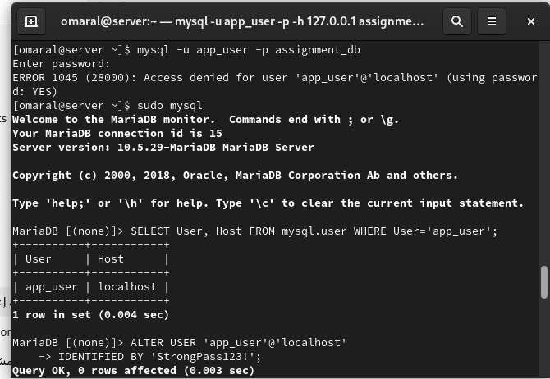
Figure 41: MySQL user authentication issue
The problem could have been solved by giving the desired privileges on the user who was already using the database and giving the stated database. This was done successfully with the help of the pertinent permissions and the reloading of the privilege tables which also made the database installation reach unity.

7.0 CONCLUSION:

In conclusion, this assignment was not a waste of time as it demonstrated how to install, configure and maintain the necessary network services in a Rocky Linux server and have a working connection on the client-side with an Ubuntu system. The DNS server has been properly configured with the BIND to respond forward and reverse queries of the domain names to ensure that the network is properly configured in terms of name resolution.
The security of the email was enhanced through email server that was built on the platforms of postfix and dovecot. The authentication credentials and email information were encrypted using the existing versions of the SSL/TLS, and tested to work with the assistance of Thunderbird email client. Also, the Apache web server was going to be used in supporting the HTTPS to ensure that the client system accessed the web in secure mode.
The other optimization of the system was achieved with the selection of MariaDB, which was the auxiliary service. The secure mode of the database server was activated, user access was limited and successful access of the user was achieved in the client machine and it displayed the relevant client-server interface with the database.
In the process of assignment, some technical issues such as failure of the DNS configuration, email authentication, browser alerts caused by using unsecure certificate and permission problem on databases were encountered. This was all negotiated and determined in a methodic way, which made the idea of troubleshooting even more worthwhile and the need to ensure that all the services are setup in a proper and similar way.
In majority of the cases, the objectives of the assignments have been achieved and the implemented services are operational and fulfill security requirements that have been established. Overall, the project was a positive field experience in the management of Linux server, network configuration, configuration, and practical issue solution with regard to security issues.

8.0 References:

Acer, M. E., Stark, E., Felt, A. P., Fahl, S., Bhargava, R., Dev, B., Braithwaite, M., Sleevi, R., & Tabriz, P. (2017). Where the Wild Warnings Are. Proceedings of the 2017 ACM SIGSAC Conference on Computer and Communications Security. https://doi.org/10.1145/3133956.3134007

Arouna, A., Fontein, R., Meijerink, B., Simulamet, I., & Jonker, M. (2025). On the Role of Forward-Confirmed reverse DNS in E-mail Authentication. https://tma.ifip.org/2025/wp-content/uploads/sites/14/2025/06/tma2025_paper33.pdf

Blechschmidt, B., & Stock, B. (2023). Extended Hell(o): A Comprehensive Large-Scale Study on Email Confidentiality and Integrity Mechanisms in the Wild Extended Hell(o): A Comprehensive Large-Scale Study on Email Confidentiality and Integrity Mechanisms in the Wild. https://www.usenix.org/system/files/usenixsecurity23-blechschmidt.pdf

Coarfa, C., Druschel, P., & Wallach, D. S. (2006). Performance analysis of TLS Web servers. ACM Transactions on Computer Systems, 24(1), 39–69. https://doi.org/10.1145/1124153.1124155

Durumeric, Z., Adrian, D., Mirian, A., Kasten, J., Bursztein, E., Lidzborski, N., Thomas, K., Eranti, V., Bailey, M., & Halderman, J. A. (2015). Neither Snow Nor Rain Nor MITM... Proceedings of the 2015 Internet Measurement Conference. https://doi.org/10.1145/2815675.2815695

Foster, I. D., Larson, J., Masich, M., Snoeren, A. C., Savage, S., & Levchenko, K. (2015). Security by Any Other Name. Proceedings of the 22nd ACM SIGSAC Conference on Computer and Communications Security - CCS ’15. https://doi.org/10.1145/2810103.2813607

Han, J., & Choi, Y. (2024). Analyzing Performance Characteristics of PostgreSQL and MariaDB on NVMeVirt. ArXiv.org. https://arxiv.org/abs/2411.10005

Holz, R., Amann, J., Mehani, O., Wachs, M., & Ali Kaafar, M. (2016). TLS in the Wild: An Internet-wide Analysis of TLS-based Protocols for Electronic Communication. Proceedings 2016 Network and Distributed System Security Symposium. https://doi.org/10.14722/ndss.2016.23055

Poddebniak, D., Ising, F., Böck, H., & Schinzel, S. (2021). Why TLS is better without STARTTLS: A Security Analysis of STARTTLS in the Email Context Why TLS is better without STARTTLS: A Security Analysis of STARTTLS in the Email Context. https://www.usenix.org/system/files/sec21-poddebniak.pdf

Sunshine, J., Egelman, S., Almuhimedi, H., Atri, N., & Cranor, L. (2002). Crying Wolf: An Empirical Study of SSL Warning Effectiveness. https://www.usenix.org/legacy/event/sec09/tech/full_papers/sunshine.pdf?q=found

Thiagarajan, K., Carisimo, E., & Bustamante, F. E. (2024). POSTER: Revealing Hidden Secrets: Decoding DNS PTR records with Large Language Models. Proceedings of the ACM SIGCOMM 2024 Conference: Posters and Demos, 10–12. https://doi.org/10.1145/3672202.3673717

van, Roland van Rijswijk-Deij, Sommese, R., Sperotto, A., & Jonker, M. (2022). Saving Brian’s privacy. https://doi.org/10.1145/3517745.3561424

Vixie, P. (1995). DNS and BIND Security Issues DNS and BIND Security Issues. https://www.usenix.org/legacy/publications/library/proceedings/security95/full_papers/vixie.pdf

3 photos of BQA Group Members
